**Question 1:**

Find out the mail servers of the following domain :

Ibm.com

Wipro.com

**ANSWER:**

**Open the kali linux in vmware and open linux terminal.**

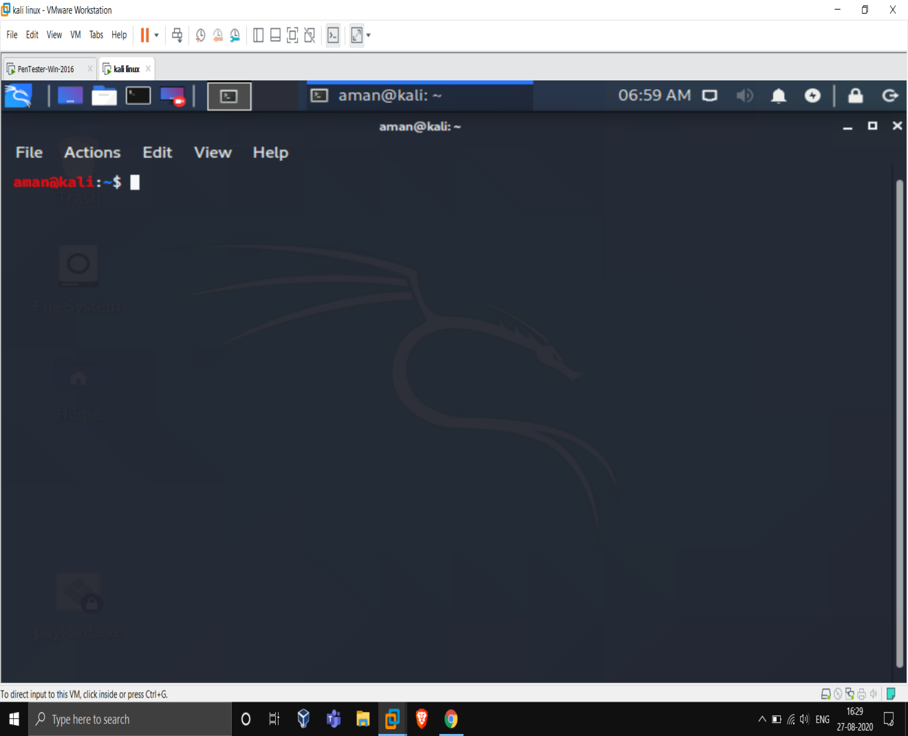

then type nslookup

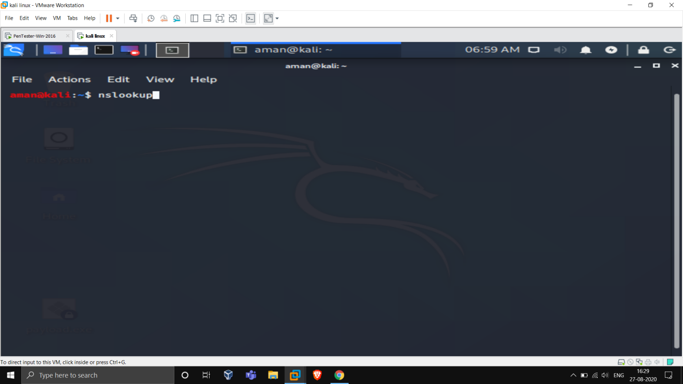

For mail server set type=mx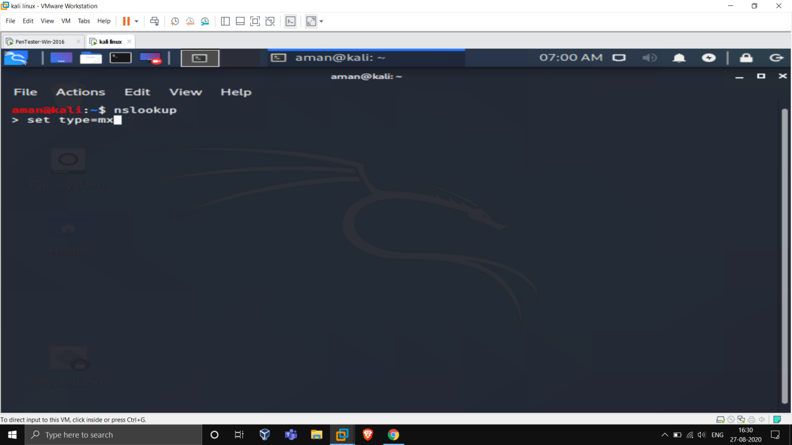

Type mail address as ibm.com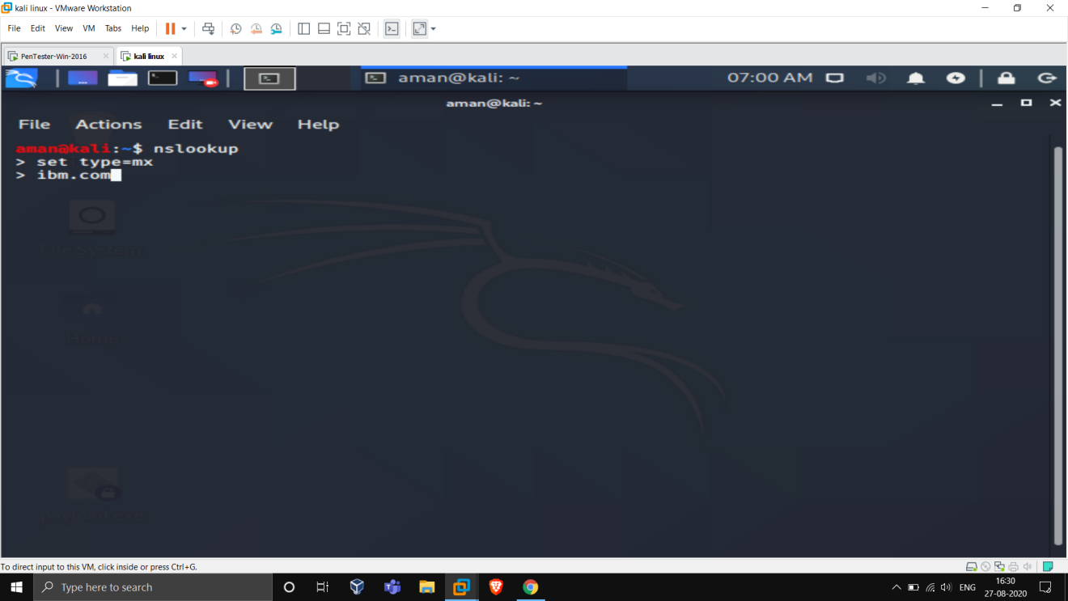

We will get our mail server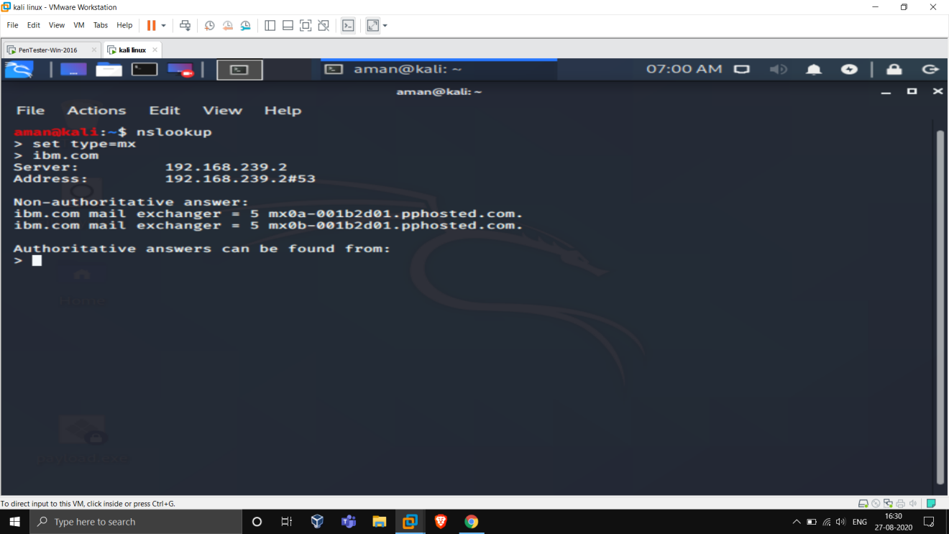

Same thing with another address: 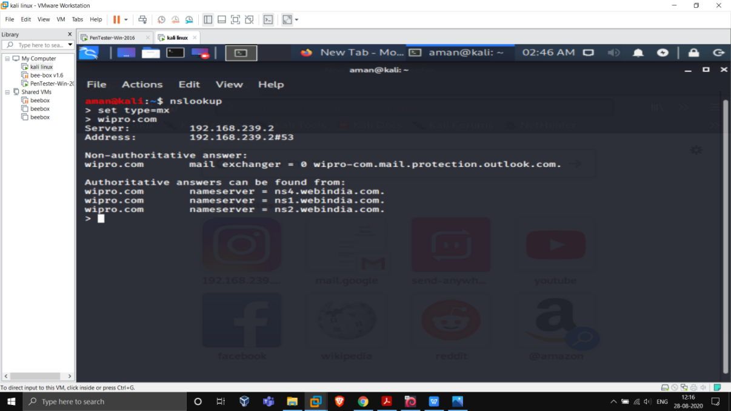

**Question 2:**

**Find the locations, where these email servers are hosted.**

**Answer:**

**We already got the mail server so, after opening terminalPing this mail server ,we will get the ip address.**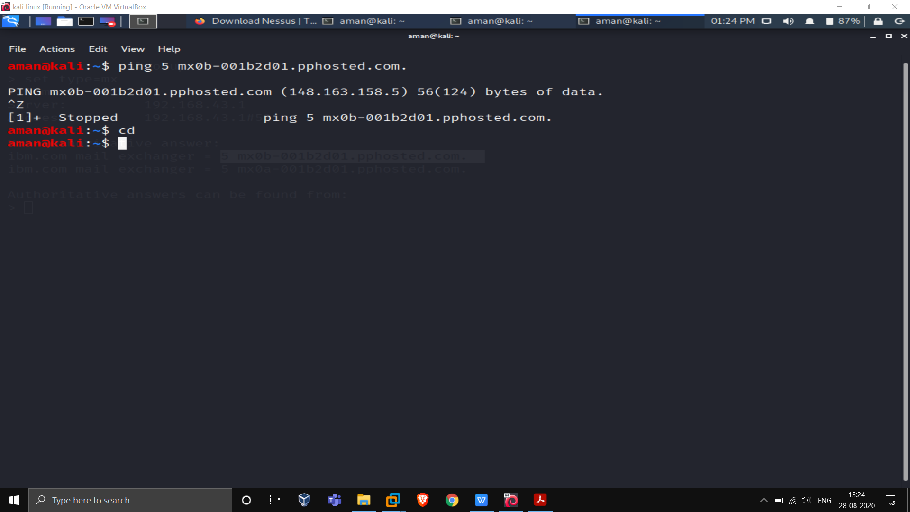

**And after that we can find ip adress location on internet**

**148.163.158.5**

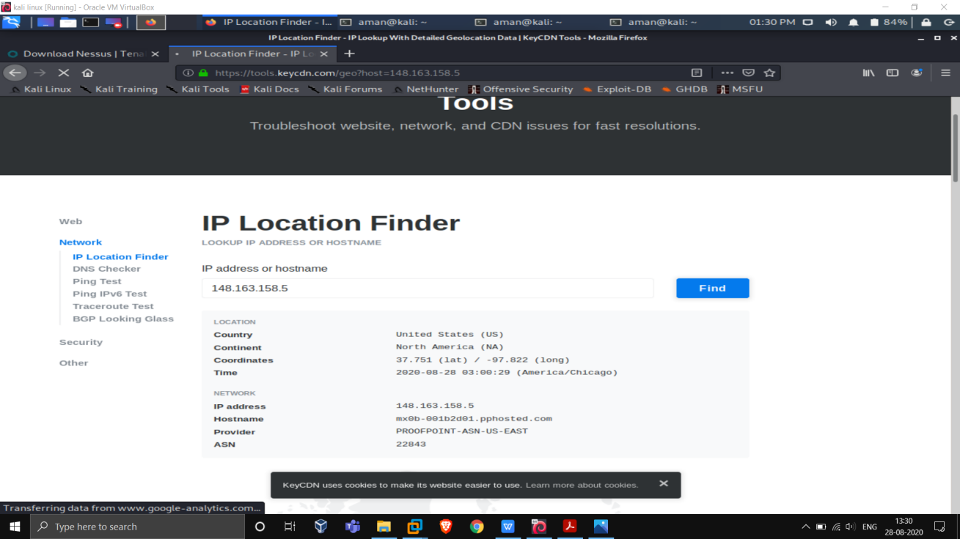

**For wipro.com**

**We got the 4 servers:**

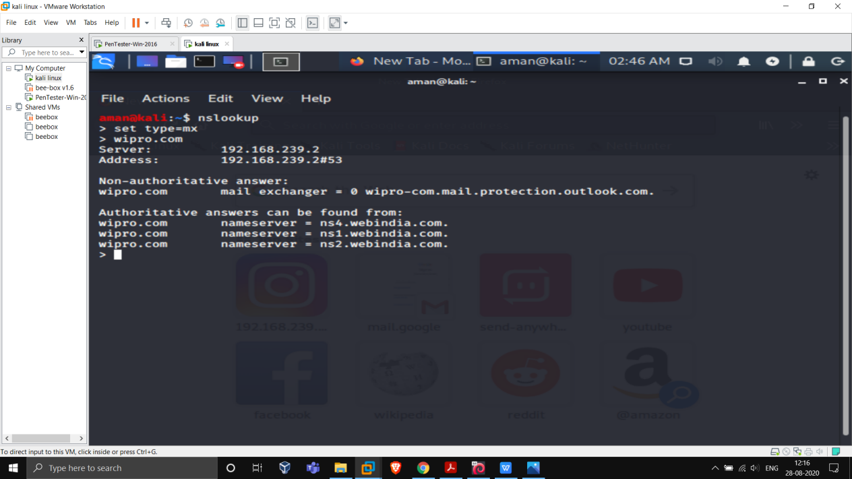

**Ping server one by one:**

**And after obtaining ip we can easily findout the location**

**For 1st server**

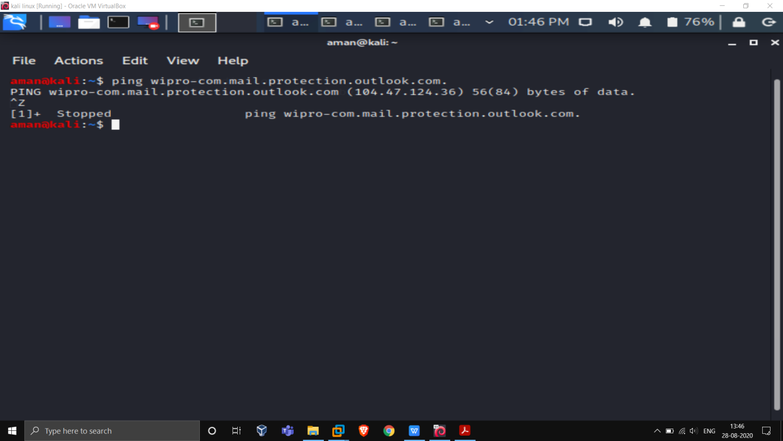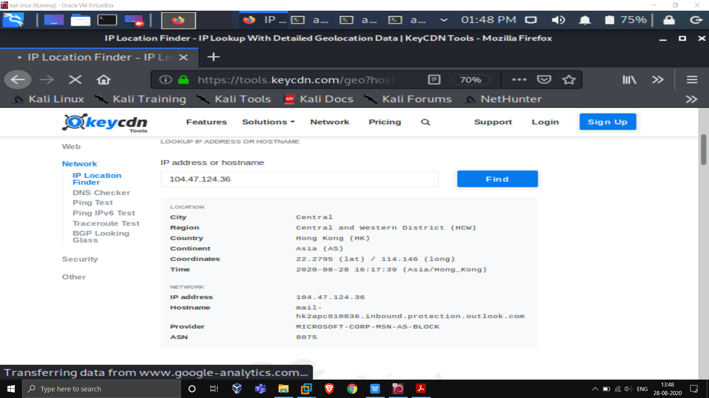

**For 2 server:**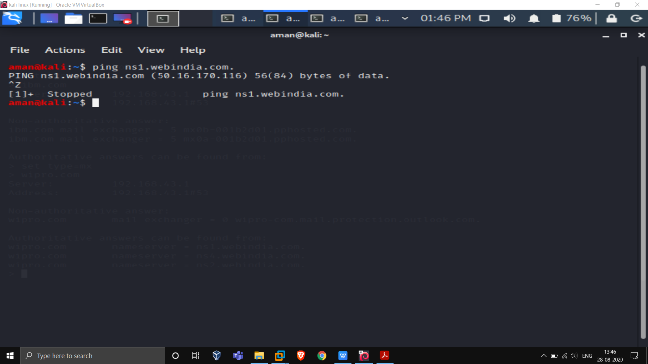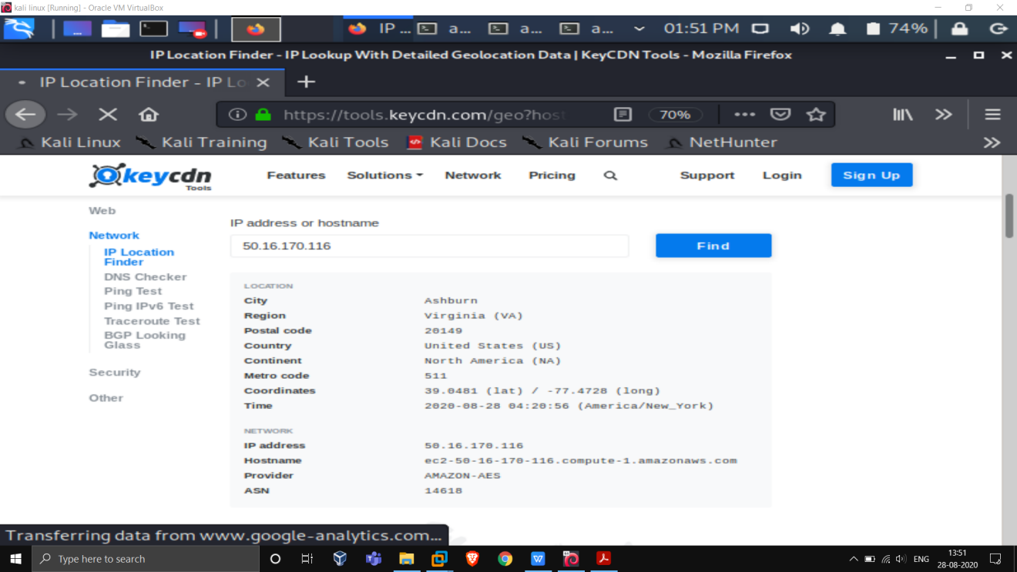

**For 3rd server:**

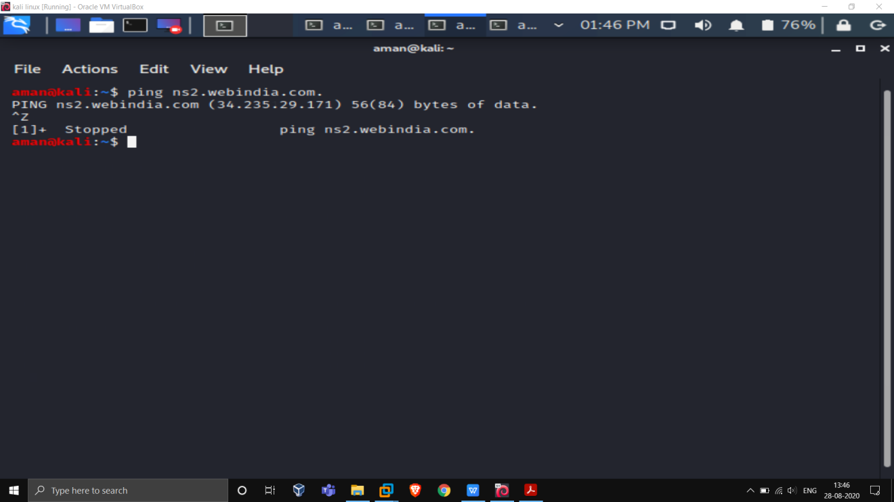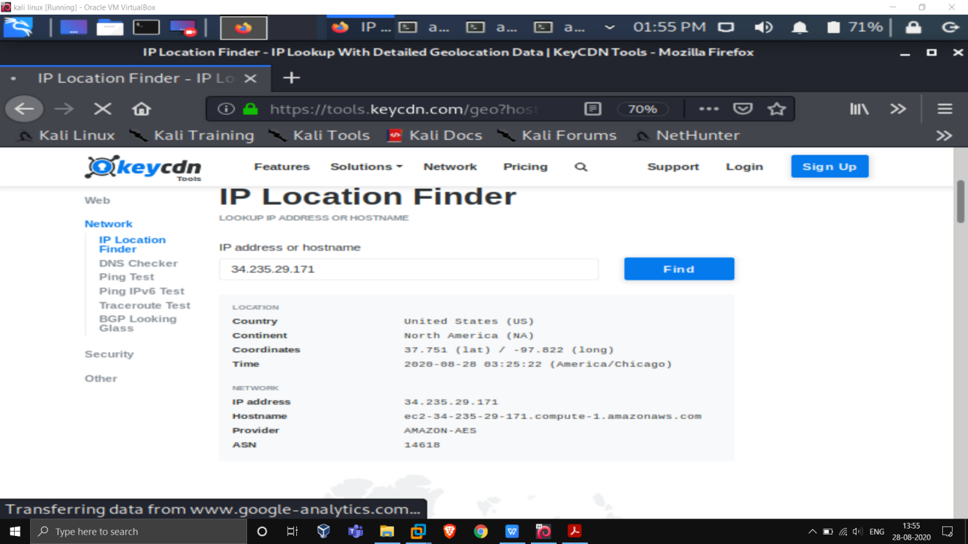

**For 4th server:**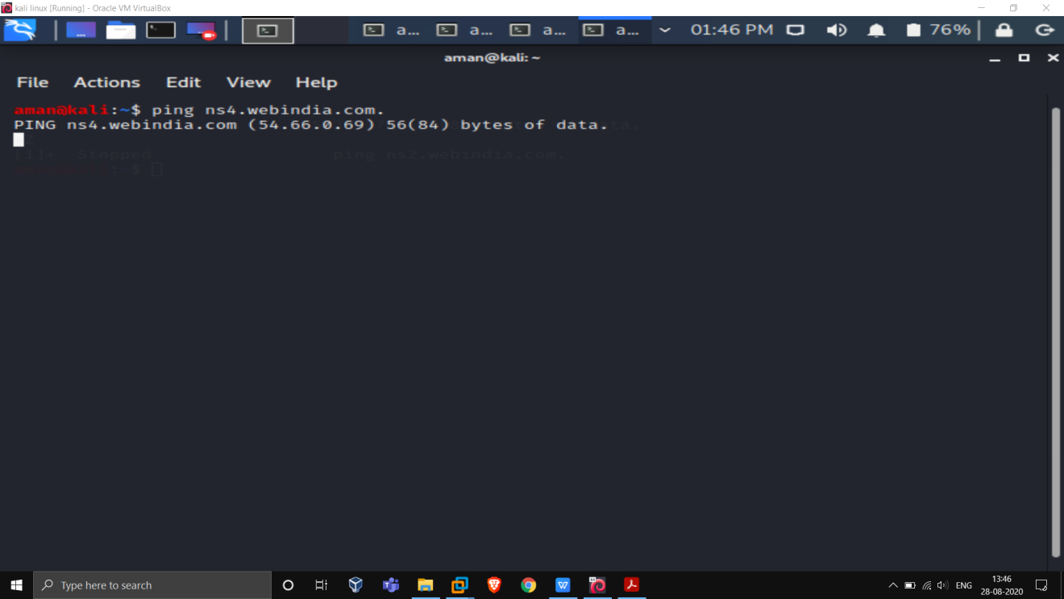

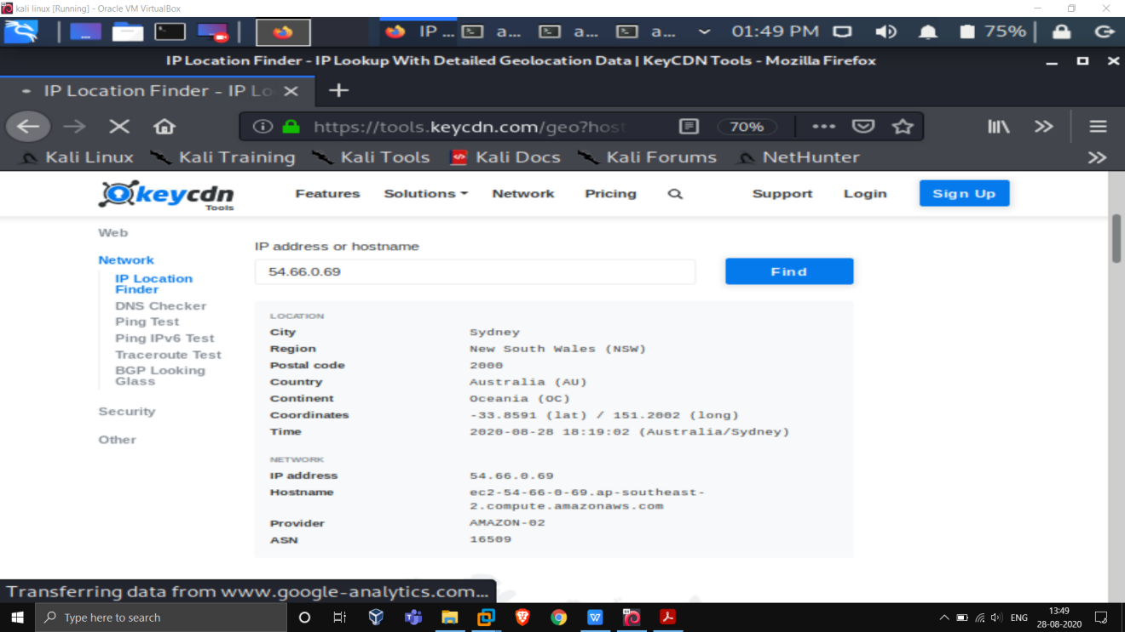

**Question 3:**

Scan and find out port numbers open 203.163.246.23

Open the kali linux terminal

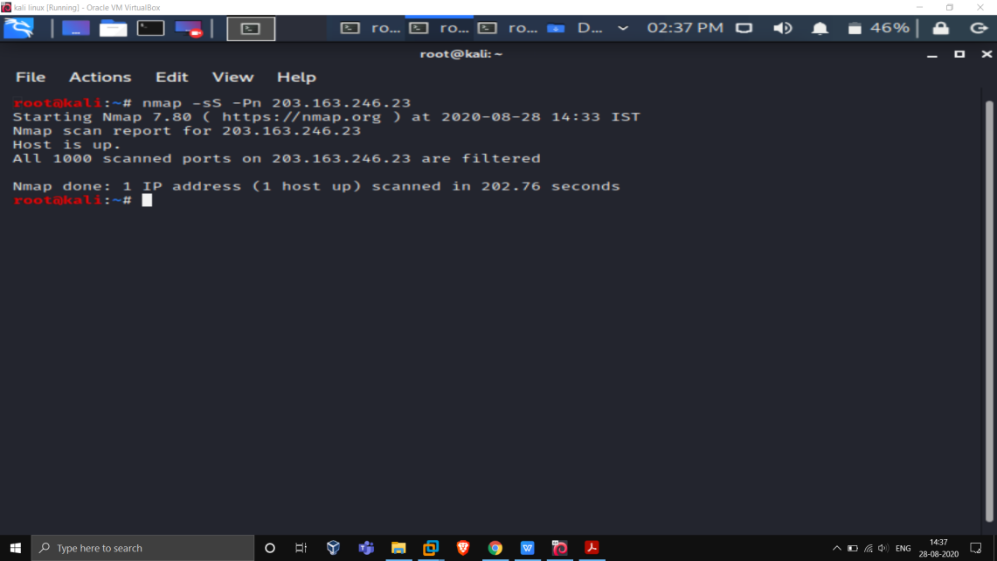

**Question 4:**

Install nessus in a VM and scan your laptop/desktop for CVE

Answer: First of we have to install nessus in kali linux

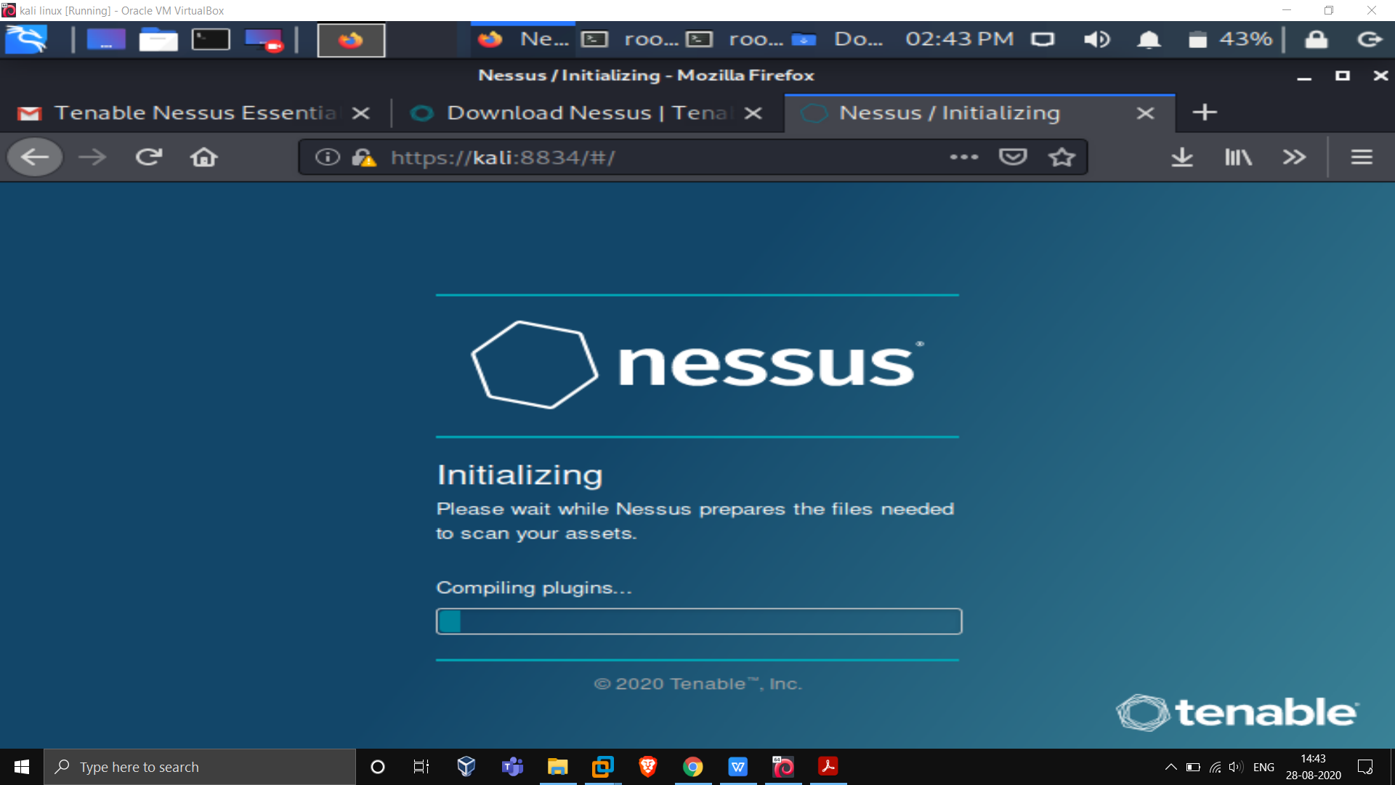

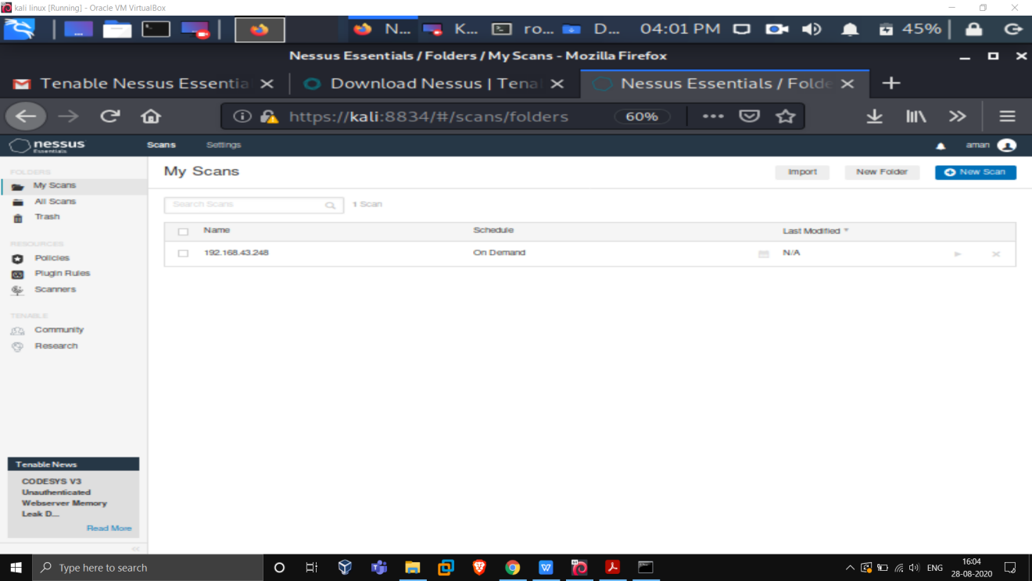

Scanning with nessus

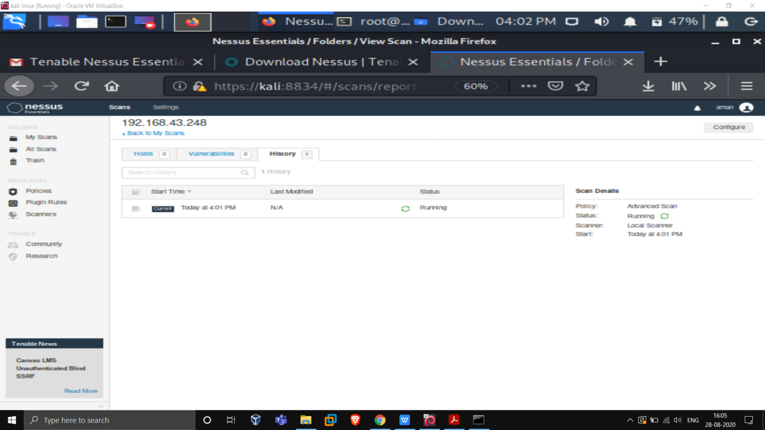

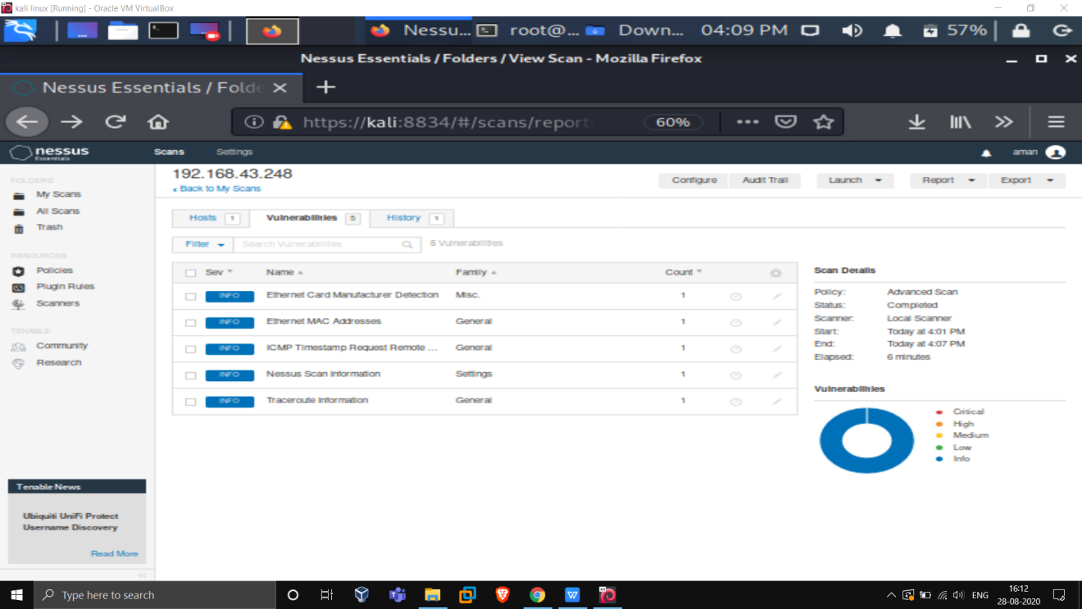

This are the valunerabilities in my system.